Information Visualization Assignment 1

If I don’t filter the countries this is how my visualization looks, which is why I have added filters for top 20/25 etc.

Visualization 1 :

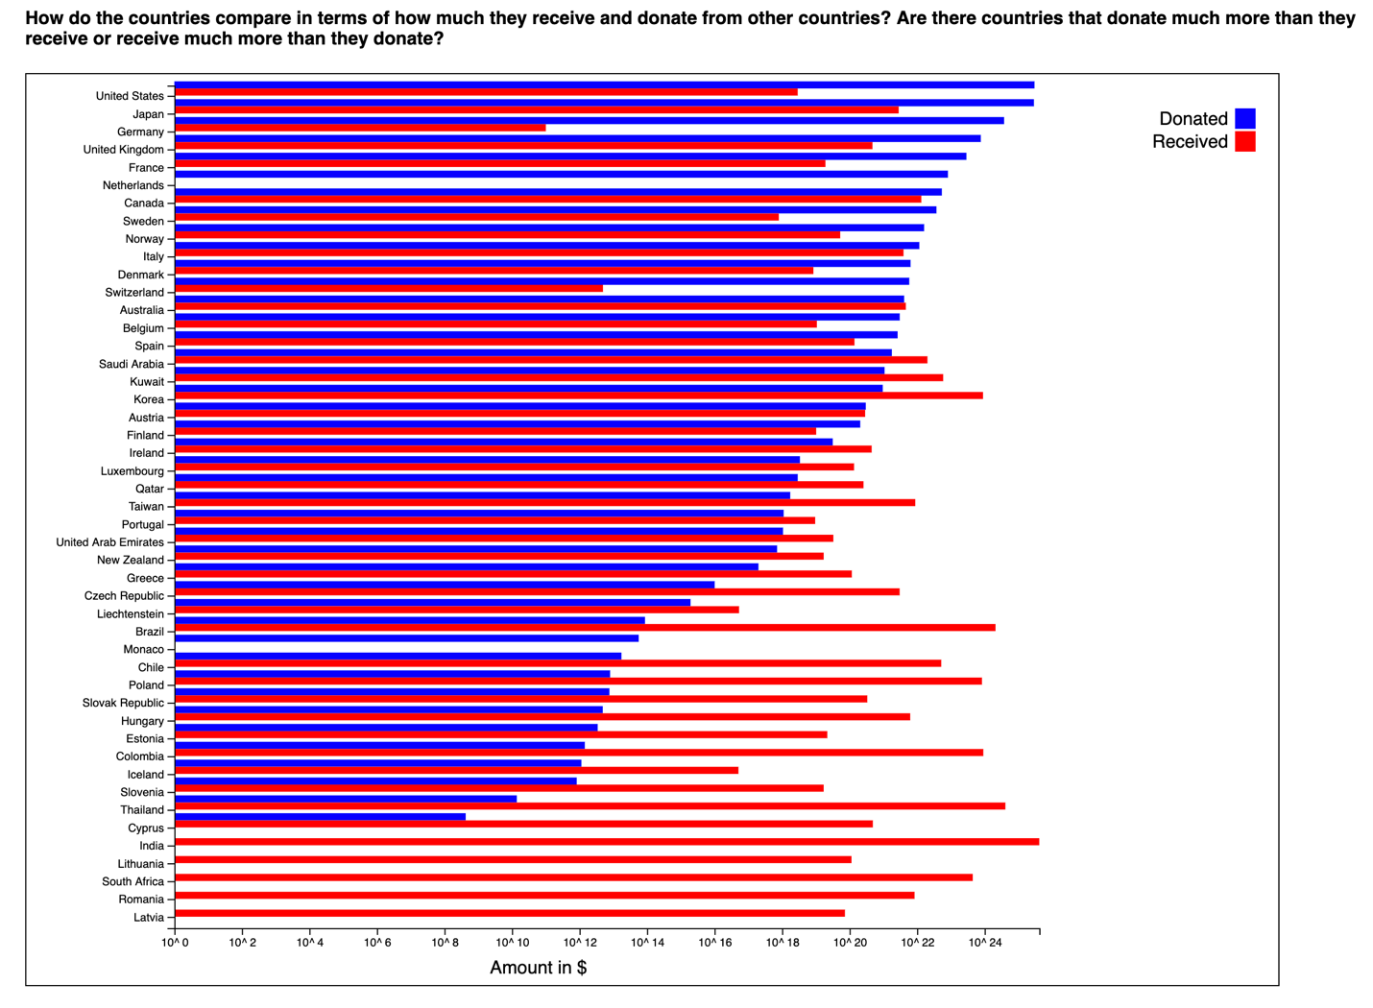

Visualization 2 :

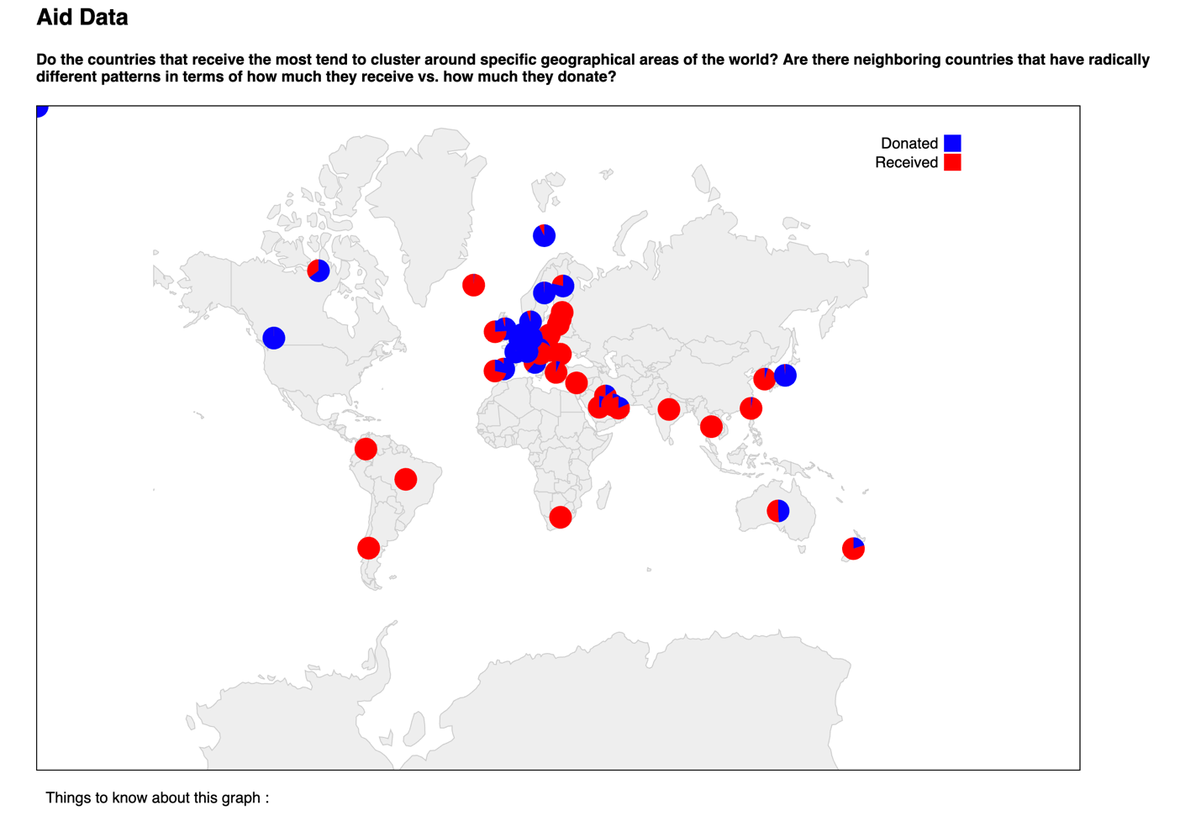

Visualization 3 :

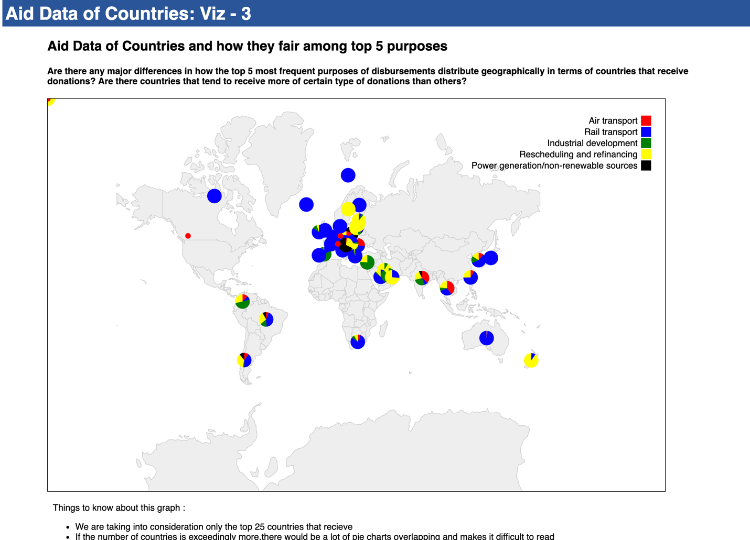

Therefore I believe filtering is one of the important things in visualization.